Contents

Insert a table of contents 1

Update when things change 2

Dive deeper than Heading 1 3

Customize your TOC 3

Remove a TOC 4

Explore more 4

Change text formatting of the TOC entries 4

Change the number of TOC levels 5

Get help in Word 6

# AZURE POWERSHELL

* PowerShell is a powerful tool for managing and automating tasks in Microsoft Azure.
* It's a cross-platform language that works with both Windows-and Linux-based machines.
* PowerShell for Azure provides a comprehensive set of cmdlets (pronounced "command-lets") that allow us to interact with various Azure services and resources.

## SETTING UP POWERSHELL – VS CODE

### VS CODE EXTENSION

1. **AZURE ACCOUNT**
2. **POWERSHELL**
3. **AZURE POWERSHELL TOOLS**

**Step 1**: To login to VS: **Connect-AzAccount -DeviceCode**



**Step 2**: Open <https://microsoft.com/devicelogin> and enter the device code

### SELECTING SUBSCRIPTION

* If we have multiple subscriptions – we can select the specific subscription.
* Step 1: Get the list of subscription : **Get-AzSubscription**

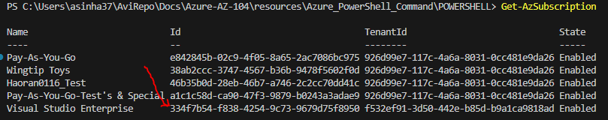

* Step 2: Set the subscription : **Select-AzSubscription -SubscriptionId "334f7b54-f838-4254-9c73-9679d75f8950"**



### VARIABLES IN POWERSHELL SCRIPTS

EXAMPLE

|  |
| --- |
| **$resourceGroup="app-grp"**  **$location="Central India"**  New-AzResourceGroup -Name **$resourceGroup** -Location **$location** |

### CREATING A RESOURCE GROUP

**$resourceGroup="app-grp"**

**$location="Central India"**

New-AzResourceGroup -Name **$resourceGroup** -Location **$location**

### CREATING A RESOURCE GROUP